**A MINI PROJECTREPORT**

**ON**

**“Virtual Programming Lab”**

Submitted in the partial fulfillment of the requirements for

The degree of

**BACHELOR of Engineering IN Computer Engineering**

**By**

1) Rhishikesh chaughule

2) vinayak kapale

3) anil sahu

4)SaNika vidhate

**UNDER THE GUIDANCE OF**

**Prof. Arpita Saxena**



Department of Computer Engineering  
Saraswati College of Engineering, Kharghar, Navi Mumbai  
University of Mumbai  
2020-21

**Saraswati College of Engineering, Kharghar**

**Vision:**

To be universally accepted as autonomous center of learning in Engineering Education and Research.

**Mission:**

* To educate students to become responsible and quality technocrats to fulfil society and industry needs.
* To nurture student’s creativity and skills for taking up challenges in all facets of life.

**_______________________________________________**

**Department of Computer Engineering**

**Vision:**

To be among renowned institution in Computer Engineering Education and Research by developing globally competent graduates.

**Mission:**

* To produce quality Engineering graduates by imparting quality training, hands on experience and value education.
* To pursue research and new technologies in Computer Engineering and across interdisciplinary areas that extends the scope of Computer Engineering and benefit humanity.
* To provide stimulating learning ambience to enhance innovative ideas, problem solving ability, leadership qualities, team-spirit and ethical responsibilities.



**DEPARTMENT OF COMPUTER ENGINEERING**

**PROGRAM EDUCATIONAL OBJECTIVE’S**

1. To embed a strong foundation of Computer Engineering fundamentals to identify, solve, analyze and design real time engineering problems as a professional or entrepreneur for the benefit of society.
2. To motivate and prepare students for lifelong learning & research to manifest global competitiveness.
3. To equip students with communication, teamwork and leadership skills to accept challenges in all the facets of life ethically.



**DEPARTMENT OF COMPUTER ENGINEERING**

**PROGRAM OUTCOMES**

1. Apply the knowledge of Mathematics, Science and Engineering Fundamentals to solve complex Computer Engineering Problems.
2. Identify, formulate and analyze Computer Engineering Problems and derive conclusion using First Principle of Mathematics, Engineering Science and Computer Science.
3. Investigate Complex Computer Engineering problems to find appropriate solution leading to valid conclusion.
4. Design a software System, components, Process to meet specified needs with appropriate attention to health and Safety Standards, Environmental and Societal Considerations.
5. Create, select and apply appropriate techniques, resources and advance Engineering software to analyze tools and design for Computer Engineering Problems.
6. Understand the Impact of Computer Engineering solution on society and environment for Sustainable development.
7. Understand Societal, health, Safety, cultural, Legal issues and Responsibilities relevant to Engineering Profession.
8. Apply Professional ethics, accountability and equity in Engineering Profession.
9. Work Effectively as a member and leader in multidisciplinary team for a common goal.
10. Communicate effectively within a Profession and Society at large.
11. Appropriately incorporate principles of Management and Finance in one’s own Work.
12. Identify educational needs and engage in lifelong learning in a Changing World of Technology.



**DEPARTMENT OF COMPUTER ENGINEERING**

**PROGRAMME SPECIFIC OUTCOME**

1. Formulate and analyze complex engineering problems in computer engineering (Networking/Big data/ Intelligent Systems/Cloud Computing/Real time systems).
2. Plan and develop efficient, reliable, secure and customized application software using cost effective emerging software tools ethically.



**(Approved by AICTE, recg. By Maharashtra Govt. DTE ,Affiliated to Mumbai University)**

**PLOT NO. 46/46A, SECTOR NO 5, BEHIND MSEB SUBSTATION, KHARGHAR, NAVI MUMBAI-410210**

**Tel. : 022-27743706 to 11 * Fax : 022-27743712 * Website: www.sce.edu.in**

**CERTIFICATE**

*This is to certify that the requirements for the mini project report entitled ”****Virtual Programming Lab****” have been successfully completed by the following students:*

Roll numbers Name

DSE_01 RHISHIKESH CHAUGHULE

DSE_03 VINAYAK KAPALE

DSE_10 ANIL SAHU

DSE_12 SANIKA VIDHATE

In partial fulfillment of Sem –IV , **Bachelor of Engineering of Mumbai University in Computer Engineering** of Saraswati college of Engineering , Kharghar during the academic year 2020-21.

**Internal Guide**  **External Examiner**

Prof. Arpita Saxena

**Mini Project Co-ordinator**  **Head of Department**

Prof. Arpita SaxenaProf. Sujata Bhairnallykar

**DECLARATION**

I declare that this written submission represents my ideas in my own words and where others ideas or words have been included. I have adequately cited and referenced the original sources. I also declare that I have adhered to all principles of academic honesty and integrity and have not misrepresented or fabricated or falsified any idea/data/fact/source in my submission. I understand that any violation of the above will be cause for disciplinary action by the Institute and can also evoke penal action from the sources which have thus not been properly cited or from whom proper permission has not been taken when needed.

1. Vinayak Kapale
2. Anil Sahu
3. Sanika Vidhate
4. Rhishikesh Chaughule

Date:

**ACKNOWLEDGEMENT**

After the completion of this work, words are not enough to express feelings about all those who helped us to reach goal.

It’s a great pleasure and moment of immense satisfaction for us to express my profound gratitude to **MiniProject Guide**, **Prof. Arpita Saxena**, whose constant encouragement enabled us to work enthusiastically. His perpetual motivation, patience and excellent expertise in discussion during progress of the project work have benefited us to an extent, which is beyond expression.

We would also like to give our sincere thanks to **Prof. Sujata Bhairnallykar, Head of Department**, and **Prof. Arpita Saxena, Mini Project co-coordinator** from Department of Computer Engineering, Saraswati college of Engineering, Kharghar, Navi Mumbai, for their guidance, encouragement and support during a project.

I am thankful to **Dr. Manjusha Deshmukh, Principal,** Saraswati College of Engineering, Kharghar, Navi Mumbai for providing an outstanding academic environment, also for providing the adequate facilities.

Last but not the least we would also like to thank all the staffs of Saraswati college of Engineering (Computer Engineering Department) for their valuable guidance with their interest and valuable suggestions brightened us.

1. Vinayak Kapale

2. Anil Sahu

1. Sanika Vidhate
2. Rhishikesh Chaughule

**Abstract**

VPL-Virtual Programming Lab is the easy way to manage programming assignments. Its features of editing, running and evaluation of programs makes learning process for students, and the evaluation task for teachers, easier than ever. Virtual labs is a web development technology. It does not require any additional infrastructural setup for conducting experiments at user premises. The simulations-based experiments can be accessed remotely via internet. This would help students in learning basic and advanced concepts through remote experimentation. VPL is an activity module that manage programming assignments and whose salient features are:

* Enable to edit the programs source code in the browser.
* Students can run interactively programs in the browser.
* Students can test their knowledge through online quiz and assignments.
* Even faculty members can do continuous assessment as per defined timeline and get feedback of conducted lab session

**Table of Contents**

|  |  |
| --- | --- |
|  |  |
| **List of Figures ………………………………………………………………………...** | **1** |
| **1. Introduction ………………………………………………………………………..** | **2** |
| **1.1 General ……………………………………………………………………..….** | **2** |
| **1.2 Objective and problem statement ……………………………........................** | **3** |
| **2. Methodology ……………………………………………………………….............** | **6** |
| **2.1 Algorithmic details .…………………………………………………………...** | **6** |
| **2.2 Hardwareand Software requirements……………………………..............** | **12** |
| **2.3 Design Details…………………………………………………………………** | **13** |
| **3. Implementation and Results …………………………………………………….** | **15** |
| **3.1. Implementation ....………………………………………………….................** | **15** |
| **3.2. Results ...………………………………………………………………............** | **16** |
| **4.Conclusion and Future Scope……………………………………………………..** | **18** |
| **5. References………………………………………………………………...........** | **19** |

# List of Figures

|  |  |  |
| --- | --- | --- |
| **Figure No.** | **Name** | **Page No.** |
|  |  |  |
|  |  |  |
|  |  |  |
|  |  |  |
|  |  |  |
|  |  |  |
|  |  |  |
|  |  |  |
|  |  |  |
|  |  |  |
|  |  |  |
|  |  |  |

**CHAPTER 1**

# INTRODUCTON

The teaching of programming is essential for the development of computer applications and for evolution of technology. The assignments of the early programming courses usually present difficulties for students and need teacher's strong monitoring, for correction and overall orientation towards correct assessment. In this context, virtual learning environment is an important tool on how to teach (and learn) programming, One of these tools is VPL (Virtual Programming Lab) a plug-in developed specifically for Moodle (Modular Object-Oriented Dynamic Learning Environment). This tool allows to edit and execute programs, in a large range of languages, and enables automatic assessment and prompt feedback VPL stores historic results about compilation and implementation of the proposed problems, tracking the student's submissions.

The use of this tool implies a paradigm shift, for the student and mainly for the teacher. This is because the teacher must plan its activities accordingly, in order to prepare assignments, configure testing environments, and validation parametrization. These tasks take a lot of time. However, after assignments, less effort is required as the student does not need so much attention and assignments grading is much easier. It is also necessary to configure Moodle, register students, create groups and, of course, prepare assignments and test cases. APROG is organized in three different types of classes: theoretical(T), theoretical-practical (TP) and practical-laboratorial (PL).

## 1.2 OBJECTIVE AND PROBLEM STATEMENT

**Objective of Proposed System:**

* To reduce the work of students as they keep on writing manuals which takes ample of time.
* The efficient way is after assignments, less effort is required as the student does not need so much attention and assignments grading is much easier using this VPL.

**Problem Statement:**

To develop a centralized system which will help students in their academics, as well as integrate a platform over which students, teachers from all departments can interact with each other for the overall growth of students.

**CHAPTER 2**

# METHODOLOGY

## 2.1 ALGORITHMIC DETAILS

**Usecase Diagram:**

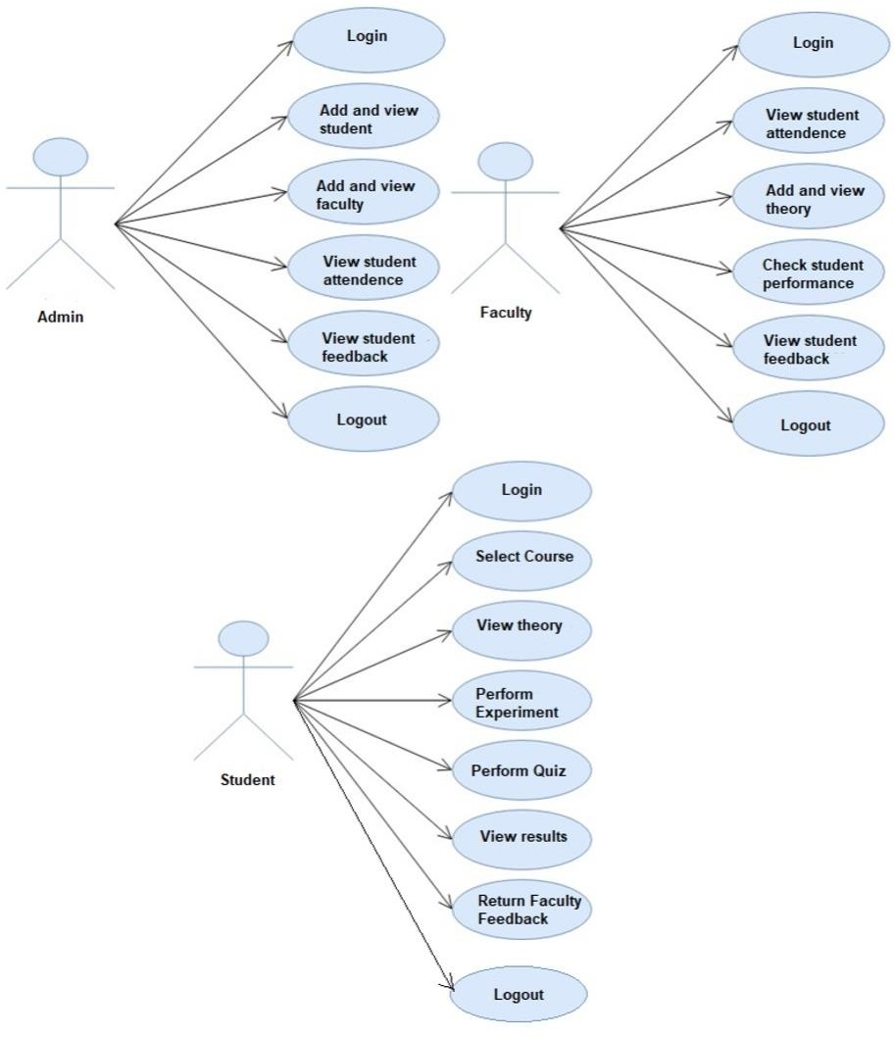

## 2.2 HARDWARE AND SOFTWARE REQUIREMENTS

**2.2.1 HARDWARE REQUIREMENTS**

1. RAM : 512 MB RAM
2. Hard Drive : 40 GB Hard Drive
3. Processor : Intel Core 2 Processor
   * 1. **SOFTWARE REQUIREMENTS**

* Languages Used:- CSS,HTML
* Platform:- Windows 10

The above specified requirements are minimum to run the application.

**2.3 DESIGN DETAILS :**

### Functional Requirements:

In functional requirement, we describe the module we require to develop this project. Functional requirements should include functions performed by specific screens, outlines of workflows performed by the system and other business or compliance requirements the system must meet.

### Interface Requirements:

* Field accepts valid data like in password entry it should be more than 8 character-length
* Field accepts numeric data entry
* Field only accepts dates before the current date

### Security Requirements:

* + Students, Teachers and Admin can use their own username and password for login.
  + Admins and teachers can view the the experiments performed by students and can change the introduction related to experiments accordingly

**CHAPTER 3**

# IMPLEMENTATION AND RESULTS

**Login Page:**

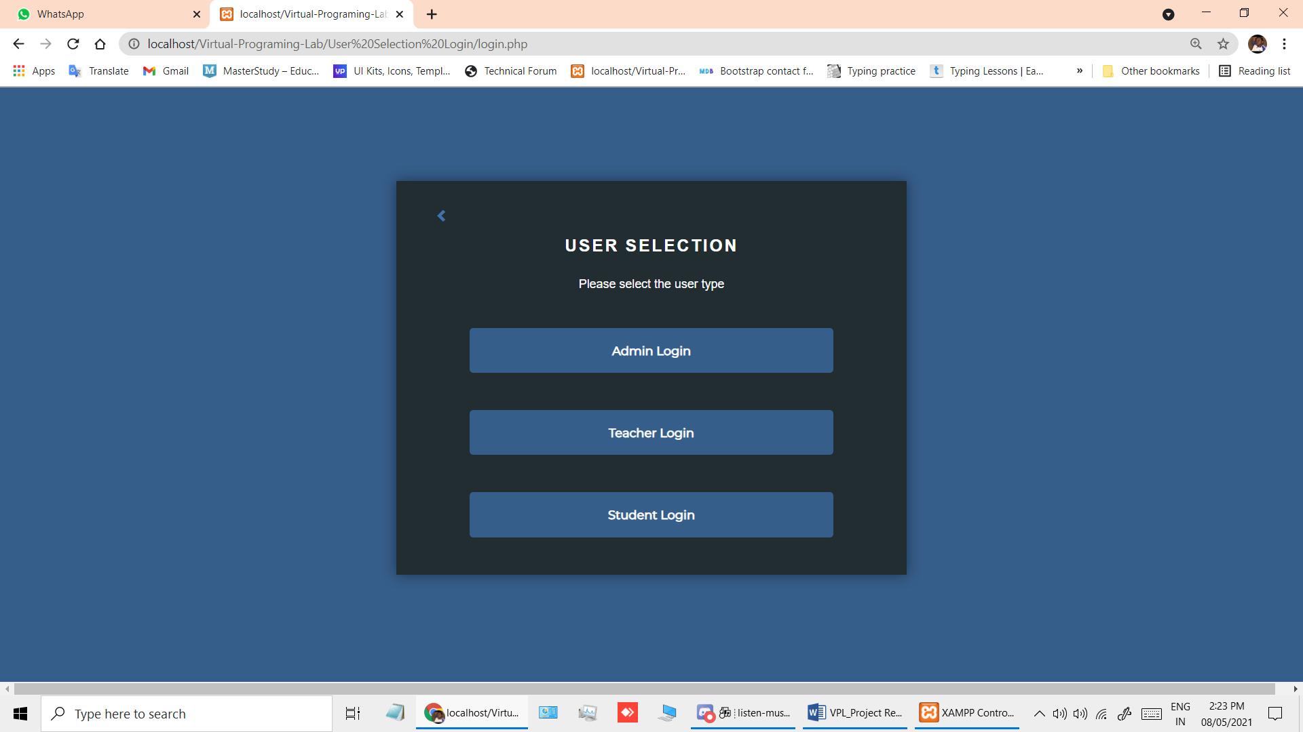

**Student Homepage:**

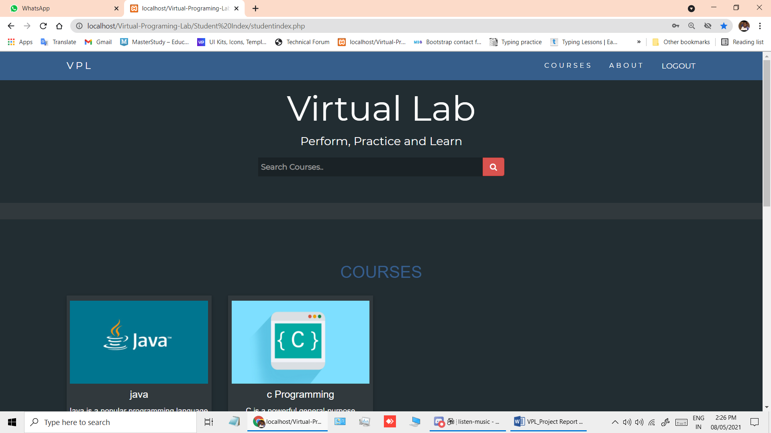

**Java Compiler Page:**

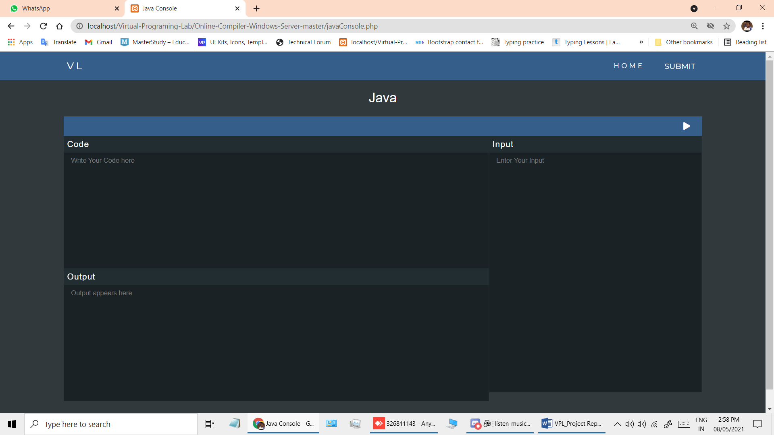

**C programming compiler:**

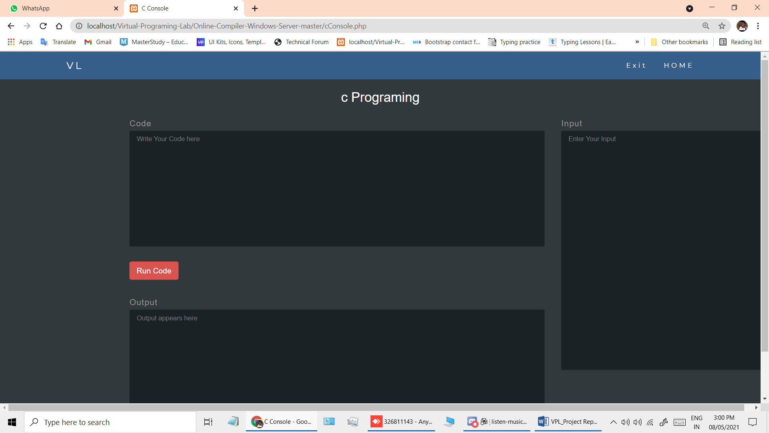

**ADMIN LOGIN**

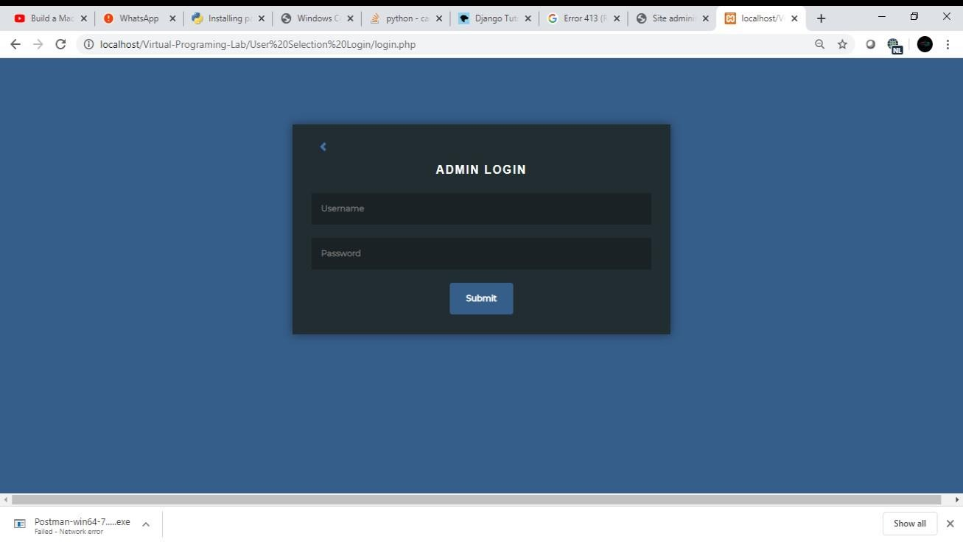

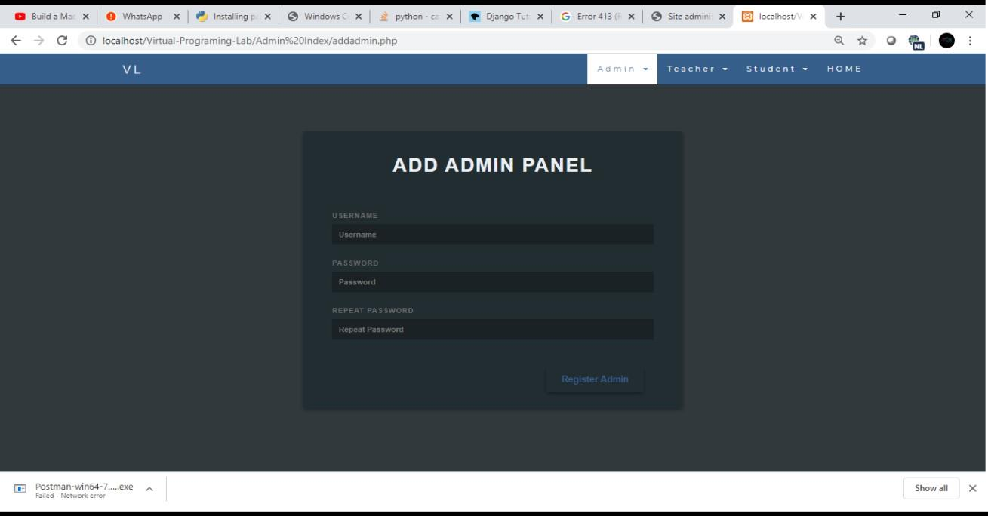

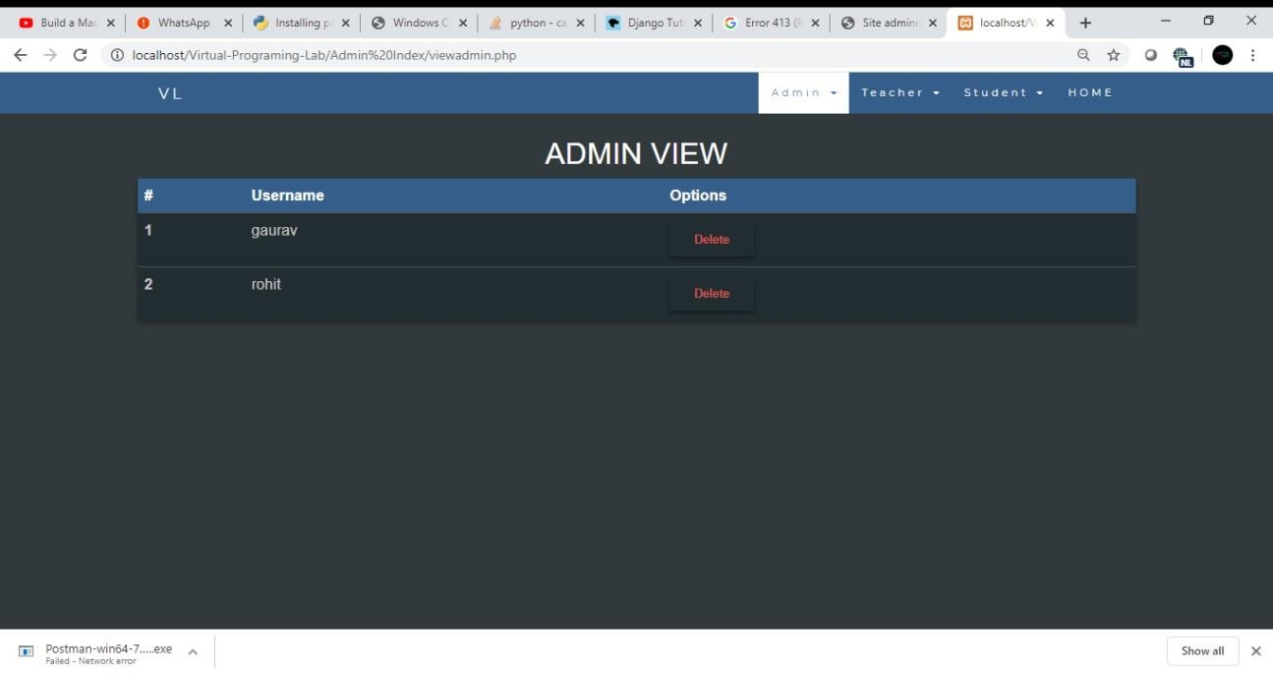

**Teacher Panel:-**

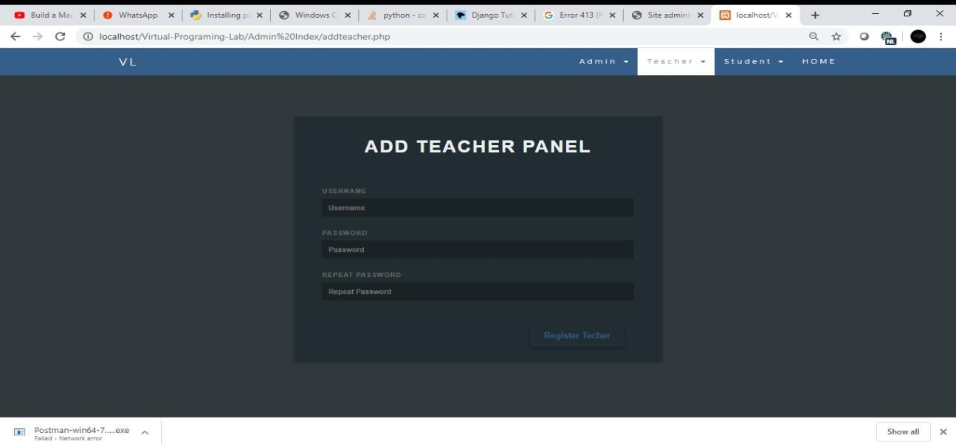

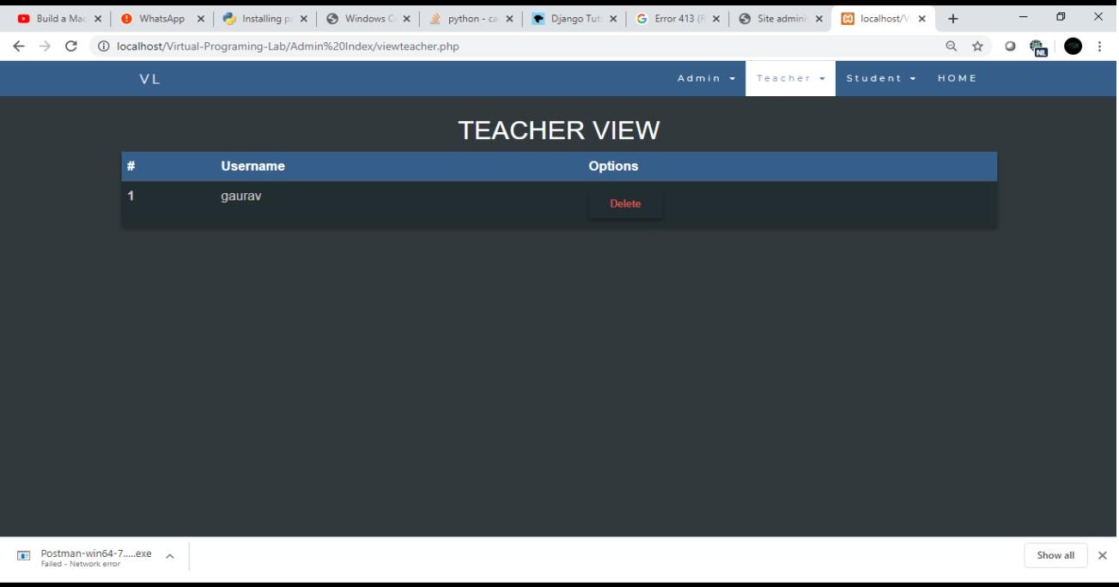

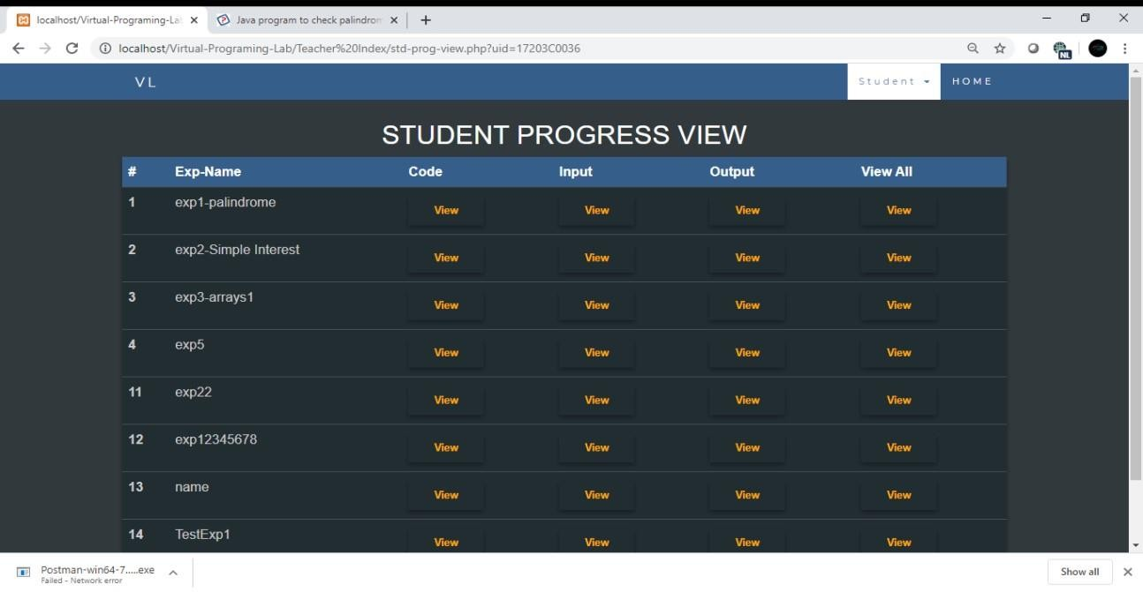

**CHAPTER 4**

# CONCLUSION AND FUTURE SCOPE

**Conclusion:**

* Thus, using these technologies VPL i.e. Virtual Programming Lab was developed for helping students increase their productivity and efficiency.
* With the help of VPL it will reduce the work of writing manuals which takes lot of time and also teachers can view the Student Progress.

**Future Scope:**

The student and mainly for the teacher. This is because the teacher must plan its activities accordingly, in order to prepare assignments, configure testing environments, and validation parametrization. These tasks take a lot of time. However, after assignments, less effort is required as the student does not need so much attention and assignments grading are much easier With this system Prospects for all these systems would include to increase their efficiency and to improve their security.

**CHAPTER 5**

# REFERENCES

* <https://getbootstrap.com/docs/4.0/examples/>
* [https://codepen.io/? cf_chl_captcha_tk=6dc9d91c30f6b3eee674c1c12c6cdb1796ec](https://codepen.io/?%20cf_chl_captcha_tk=6dc9d91c30f6b3eee674c1c12c6cdb1796ec) [2cd7-1588451736-0-](https://codepen.io/?__cf_chl_captcha_tk__=6dc9d91c30f6b3eee674c1c12c6cdb1796ec2cd7-1588451736-0-ARNBgooOlwCe7CPgEvWqBNLDVEF35m7IztNyui1QGTrqt6ZBDlYJVB2BDv5mCoxjT-TxwiCScFsyoj5Fs_WPvYDZvmJ60hQ3Rkhd0HXzegcSklF6k89gN5H0vXNHZ3E6UdTuZ4j_6rtSZtumwElUL53D20w949lJRHPmVmXuX3ZfD6bHpFJrAUq3QDlDe-1cj2LVacUlTl7_fogEa5G3kZzCZJxL-cqH518QU9aUnTmntuZG6M4Fj5cm8xk1DgqQ5yAUS5uVTENfpmLK6biCRMeBW0i748KLKKfosdqpdVcvfUia7nYRL2b5yCC8Lc1KHGaX0hXJ753xgODEMuDTT8-AFGAS4ORYbM3CdZruPpXyRTOHETJ_G_V9R7G_jAo-6w1XAwe5LmUKpVtyjMNMwXCQfmyo8j1krIHIz7IR7YVviK8qOlubPPDQ81tFz-5bS-BxXRcXz5bLKPqYBpe2WGjti77TOZDbeYTzYbJ6d7ZxSbUizk5pwBAw05g9XHZ2kXHf0hqFOy1kcwpfus_jhRc9UcqX8QYDUrC_YP-FkPld) [ARNBgooOlwCe7CPgEvWqBNLDVEF35m7IztNyui1QGTrqt6ZBDlYJVB2BDv5mCoxjT-](https://codepen.io/?__cf_chl_captcha_tk__=6dc9d91c30f6b3eee674c1c12c6cdb1796ec2cd7-1588451736-0-ARNBgooOlwCe7CPgEvWqBNLDVEF35m7IztNyui1QGTrqt6ZBDlYJVB2BDv5mCoxjT-TxwiCScFsyoj5Fs_WPvYDZvmJ60hQ3Rkhd0HXzegcSklF6k89gN5H0vXNHZ3E6UdTuZ4j_6rtSZtumwElUL53D20w949lJRHPmVmXuX3ZfD6bHpFJrAUq3QDlDe-1cj2LVacUlTl7_fogEa5G3kZzCZJxL-cqH518QU9aUnTmntuZG6M4Fj5cm8xk1DgqQ5yAUS5uVTENfpmLK6biCRMeBW0i748KLKKfosdqpdVcvfUia7nYRL2b5yCC8Lc1KHGaX0hXJ753xgODEMuDTT8-AFGAS4ORYbM3CdZruPpXyRTOHETJ_G_V9R7G_jAo-6w1XAwe5LmUKpVtyjMNMwXCQfmyo8j1krIHIz7IR7YVviK8qOlubPPDQ81tFz-5bS-BxXRcXz5bLKPqYBpe2WGjti77TOZDbeYTzYbJ6d7ZxSbUizk5pwBAw05g9XHZ2kXHf0hqFOy1kcwpfus_jhRc9UcqX8QYDUrC_YP-FkPld) [TxwiCScFsyoj5Fs_WPvYDZvmJ60hQ3Rkhd0HXzegcSklF6k89gN5H0vXNHZ3E6UdTu](https://codepen.io/?__cf_chl_captcha_tk__=6dc9d91c30f6b3eee674c1c12c6cdb1796ec2cd7-1588451736-0-ARNBgooOlwCe7CPgEvWqBNLDVEF35m7IztNyui1QGTrqt6ZBDlYJVB2BDv5mCoxjT-TxwiCScFsyoj5Fs_WPvYDZvmJ60hQ3Rkhd0HXzegcSklF6k89gN5H0vXNHZ3E6UdTuZ4j_6rtSZtumwElUL53D20w949lJRHPmVmXuX3ZfD6bHpFJrAUq3QDlDe-1cj2LVacUlTl7_fogEa5G3kZzCZJxL-cqH518QU9aUnTmntuZG6M4Fj5cm8xk1DgqQ5yAUS5uVTENfpmLK6biCRMeBW0i748KLKKfosdqpdVcvfUia7nYRL2b5yCC8Lc1KHGaX0hXJ753xgODEMuDTT8-AFGAS4ORYbM3CdZruPpXyRTOHETJ_G_V9R7G_jAo-6w1XAwe5LmUKpVtyjMNMwXCQfmyo8j1krIHIz7IR7YVviK8qOlubPPDQ81tFz-5bS-BxXRcXz5bLKPqYBpe2WGjti77TOZDbeYTzYbJ6d7ZxSbUizk5pwBAw05g9XHZ2kXHf0hqFOy1kcwpfus_jhRc9UcqX8QYDUrC_YP-FkPld) [Z4j_6rtSZtumwElUL53D20w949lJRHPmVmXuX3ZfD6bHpFJrAUq3QDlDe-](https://codepen.io/?__cf_chl_captcha_tk__=6dc9d91c30f6b3eee674c1c12c6cdb1796ec2cd7-1588451736-0-ARNBgooOlwCe7CPgEvWqBNLDVEF35m7IztNyui1QGTrqt6ZBDlYJVB2BDv5mCoxjT-TxwiCScFsyoj5Fs_WPvYDZvmJ60hQ3Rkhd0HXzegcSklF6k89gN5H0vXNHZ3E6UdTuZ4j_6rtSZtumwElUL53D20w949lJRHPmVmXuX3ZfD6bHpFJrAUq3QDlDe-1cj2LVacUlTl7_fogEa5G3kZzCZJxL-cqH518QU9aUnTmntuZG6M4Fj5cm8xk1DgqQ5yAUS5uVTENfpmLK6biCRMeBW0i748KLKKfosdqpdVcvfUia7nYRL2b5yCC8Lc1KHGaX0hXJ753xgODEMuDTT8-AFGAS4ORYbM3CdZruPpXyRTOHETJ_G_V9R7G_jAo-6w1XAwe5LmUKpVtyjMNMwXCQfmyo8j1krIHIz7IR7YVviK8qOlubPPDQ81tFz-5bS-BxXRcXz5bLKPqYBpe2WGjti77TOZDbeYTzYbJ6d7ZxSbUizk5pwBAw05g9XHZ2kXHf0hqFOy1kcwpfus_jhRc9UcqX8QYDUrC_YP-FkPld) [1cj2LVacUlTl7_fogEa5G3kZzCZJxL-](https://codepen.io/?__cf_chl_captcha_tk__=6dc9d91c30f6b3eee674c1c12c6cdb1796ec2cd7-1588451736-0-ARNBgooOlwCe7CPgEvWqBNLDVEF35m7IztNyui1QGTrqt6ZBDlYJVB2BDv5mCoxjT-TxwiCScFsyoj5Fs_WPvYDZvmJ60hQ3Rkhd0HXzegcSklF6k89gN5H0vXNHZ3E6UdTuZ4j_6rtSZtumwElUL53D20w949lJRHPmVmXuX3ZfD6bHpFJrAUq3QDlDe-1cj2LVacUlTl7_fogEa5G3kZzCZJxL-cqH518QU9aUnTmntuZG6M4Fj5cm8xk1DgqQ5yAUS5uVTENfpmLK6biCRMeBW0i748KLKKfosdqpdVcvfUia7nYRL2b5yCC8Lc1KHGaX0hXJ753xgODEMuDTT8-AFGAS4ORYbM3CdZruPpXyRTOHETJ_G_V9R7G_jAo-6w1XAwe5LmUKpVtyjMNMwXCQfmyo8j1krIHIz7IR7YVviK8qOlubPPDQ81tFz-5bS-BxXRcXz5bLKPqYBpe2WGjti77TOZDbeYTzYbJ6d7ZxSbUizk5pwBAw05g9XHZ2kXHf0hqFOy1kcwpfus_jhRc9UcqX8QYDUrC_YP-FkPld) [cqH518QU9aUnTmntuZG6M4Fj5cm8xk1DgqQ5yAUS5uVTENfpmLK6biCRMeBW0i748](https://codepen.io/?__cf_chl_captcha_tk__=6dc9d91c30f6b3eee674c1c12c6cdb1796ec2cd7-1588451736-0-ARNBgooOlwCe7CPgEvWqBNLDVEF35m7IztNyui1QGTrqt6ZBDlYJVB2BDv5mCoxjT-TxwiCScFsyoj5Fs_WPvYDZvmJ60hQ3Rkhd0HXzegcSklF6k89gN5H0vXNHZ3E6UdTuZ4j_6rtSZtumwElUL53D20w949lJRHPmVmXuX3ZfD6bHpFJrAUq3QDlDe-1cj2LVacUlTl7_fogEa5G3kZzCZJxL-cqH518QU9aUnTmntuZG6M4Fj5cm8xk1DgqQ5yAUS5uVTENfpmLK6biCRMeBW0i748KLKKfosdqpdVcvfUia7nYRL2b5yCC8Lc1KHGaX0hXJ753xgODEMuDTT8-AFGAS4ORYbM3CdZruPpXyRTOHETJ_G_V9R7G_jAo-6w1XAwe5LmUKpVtyjMNMwXCQfmyo8j1krIHIz7IR7YVviK8qOlubPPDQ81tFz-5bS-BxXRcXz5bLKPqYBpe2WGjti77TOZDbeYTzYbJ6d7ZxSbUizk5pwBAw05g9XHZ2kXHf0hqFOy1kcwpfus_jhRc9UcqX8QYDUrC_YP-FkPld) [KLKKfosdqpdVcvfUia7nYRL2b5yCC8Lc1KHGaX0hXJ753xgODEMuDTT8-](https://codepen.io/?__cf_chl_captcha_tk__=6dc9d91c30f6b3eee674c1c12c6cdb1796ec2cd7-1588451736-0-ARNBgooOlwCe7CPgEvWqBNLDVEF35m7IztNyui1QGTrqt6ZBDlYJVB2BDv5mCoxjT-TxwiCScFsyoj5Fs_WPvYDZvmJ60hQ3Rkhd0HXzegcSklF6k89gN5H0vXNHZ3E6UdTuZ4j_6rtSZtumwElUL53D20w949lJRHPmVmXuX3ZfD6bHpFJrAUq3QDlDe-1cj2LVacUlTl7_fogEa5G3kZzCZJxL-cqH518QU9aUnTmntuZG6M4Fj5cm8xk1DgqQ5yAUS5uVTENfpmLK6biCRMeBW0i748KLKKfosdqpdVcvfUia7nYRL2b5yCC8Lc1KHGaX0hXJ753xgODEMuDTT8-AFGAS4ORYbM3CdZruPpXyRTOHETJ_G_V9R7G_jAo-6w1XAwe5LmUKpVtyjMNMwXCQfmyo8j1krIHIz7IR7YVviK8qOlubPPDQ81tFz-5bS-BxXRcXz5bLKPqYBpe2WGjti77TOZDbeYTzYbJ6d7ZxSbUizk5pwBAw05g9XHZ2kXHf0hqFOy1kcwpfus_jhRc9UcqX8QYDUrC_YP-FkPld) [AFGAS4ORYbM3CdZruPpXyRTOHETJ_G_V9R7G_jAo-](https://codepen.io/?__cf_chl_captcha_tk__=6dc9d91c30f6b3eee674c1c12c6cdb1796ec2cd7-1588451736-0-ARNBgooOlwCe7CPgEvWqBNLDVEF35m7IztNyui1QGTrqt6ZBDlYJVB2BDv5mCoxjT-TxwiCScFsyoj5Fs_WPvYDZvmJ60hQ3Rkhd0HXzegcSklF6k89gN5H0vXNHZ3E6UdTuZ4j_6rtSZtumwElUL53D20w949lJRHPmVmXuX3ZfD6bHpFJrAUq3QDlDe-1cj2LVacUlTl7_fogEa5G3kZzCZJxL-cqH518QU9aUnTmntuZG6M4Fj5cm8xk1DgqQ5yAUS5uVTENfpmLK6biCRMeBW0i748KLKKfosdqpdVcvfUia7nYRL2b5yCC8Lc1KHGaX0hXJ753xgODEMuDTT8-AFGAS4ORYbM3CdZruPpXyRTOHETJ_G_V9R7G_jAo-6w1XAwe5LmUKpVtyjMNMwXCQfmyo8j1krIHIz7IR7YVviK8qOlubPPDQ81tFz-5bS-BxXRcXz5bLKPqYBpe2WGjti77TOZDbeYTzYbJ6d7ZxSbUizk5pwBAw05g9XHZ2kXHf0hqFOy1kcwpfus_jhRc9UcqX8QYDUrC_YP-FkPld) [6w1XAwe5LmUKpVtyjMNMwXCQfmyo8j1krIHIz7IR7YVviK8qOlubPPDQ81tFz-5bS-](https://codepen.io/?__cf_chl_captcha_tk__=6dc9d91c30f6b3eee674c1c12c6cdb1796ec2cd7-1588451736-0-ARNBgooOlwCe7CPgEvWqBNLDVEF35m7IztNyui1QGTrqt6ZBDlYJVB2BDv5mCoxjT-TxwiCScFsyoj5Fs_WPvYDZvmJ60hQ3Rkhd0HXzegcSklF6k89gN5H0vXNHZ3E6UdTuZ4j_6rtSZtumwElUL53D20w949lJRHPmVmXuX3ZfD6bHpFJrAUq3QDlDe-1cj2LVacUlTl7_fogEa5G3kZzCZJxL-cqH518QU9aUnTmntuZG6M4Fj5cm8xk1DgqQ5yAUS5uVTENfpmLK6biCRMeBW0i748KLKKfosdqpdVcvfUia7nYRL2b5yCC8Lc1KHGaX0hXJ753xgODEMuDTT8-AFGAS4ORYbM3CdZruPpXyRTOHETJ_G_V9R7G_jAo-6w1XAwe5LmUKpVtyjMNMwXCQfmyo8j1krIHIz7IR7YVviK8qOlubPPDQ81tFz-5bS-BxXRcXz5bLKPqYBpe2WGjti77TOZDbeYTzYbJ6d7ZxSbUizk5pwBAw05g9XHZ2kXHf0hqFOy1kcwpfus_jhRc9UcqX8QYDUrC_YP-FkPld) [BxXRcXz5bLKPqYBpe2WGjti77TOZDbeYTzYbJ6d7ZxSbUizk5pwBAw05g9XHZ2kXHf](https://codepen.io/?__cf_chl_captcha_tk__=6dc9d91c30f6b3eee674c1c12c6cdb1796ec2cd7-1588451736-0-ARNBgooOlwCe7CPgEvWqBNLDVEF35m7IztNyui1QGTrqt6ZBDlYJVB2BDv5mCoxjT-TxwiCScFsyoj5Fs_WPvYDZvmJ60hQ3Rkhd0HXzegcSklF6k89gN5H0vXNHZ3E6UdTuZ4j_6rtSZtumwElUL53D20w949lJRHPmVmXuX3ZfD6bHpFJrAUq3QDlDe-1cj2LVacUlTl7_fogEa5G3kZzCZJxL-cqH518QU9aUnTmntuZG6M4Fj5cm8xk1DgqQ5yAUS5uVTENfpmLK6biCRMeBW0i748KLKKfosdqpdVcvfUia7nYRL2b5yCC8Lc1KHGaX0hXJ753xgODEMuDTT8-AFGAS4ORYbM3CdZruPpXyRTOHETJ_G_V9R7G_jAo-6w1XAwe5LmUKpVtyjMNMwXCQfmyo8j1krIHIz7IR7YVviK8qOlubPPDQ81tFz-5bS-BxXRcXz5bLKPqYBpe2WGjti77TOZDbeYTzYbJ6d7ZxSbUizk5pwBAw05g9XHZ2kXHf0hqFOy1kcwpfus_jhRc9UcqX8QYDUrC_YP-FkPld) [0hqFOy1kcwpfus_jhRc9UcqX8QYDUrC_YP-FkPld](https://codepen.io/?__cf_chl_captcha_tk__=6dc9d91c30f6b3eee674c1c12c6cdb1796ec2cd7-1588451736-0-ARNBgooOlwCe7CPgEvWqBNLDVEF35m7IztNyui1QGTrqt6ZBDlYJVB2BDv5mCoxjT-TxwiCScFsyoj5Fs_WPvYDZvmJ60hQ3Rkhd0HXzegcSklF6k89gN5H0vXNHZ3E6UdTuZ4j_6rtSZtumwElUL53D20w949lJRHPmVmXuX3ZfD6bHpFJrAUq3QDlDe-1cj2LVacUlTl7_fogEa5G3kZzCZJxL-cqH518QU9aUnTmntuZG6M4Fj5cm8xk1DgqQ5yAUS5uVTENfpmLK6biCRMeBW0i748KLKKfosdqpdVcvfUia7nYRL2b5yCC8Lc1KHGaX0hXJ753xgODEMuDTT8-AFGAS4ORYbM3CdZruPpXyRTOHETJ_G_V9R7G_jAo-6w1XAwe5LmUKpVtyjMNMwXCQfmyo8j1krIHIz7IR7YVviK8qOlubPPDQ81tFz-5bS-BxXRcXz5bLKPqYBpe2WGjti77TOZDbeYTzYbJ6d7ZxSbUizk5pwBAw05g9XHZ2kXHf0hqFOy1kcwpfus_jhRc9UcqX8QYDUrC_YP-FkPld)